**SYNOPSIS**

**Report on**

**JAVA BRAINS**

**by**

SHIVANI SHARMA

ROLL NUMBER: 2200290140147

**Session:2023-2024 (III Semester)**

Under the supervision of

**DR. AMIT KUMAR**

**(ASSISTANT PROFESSOR)**

### KIET Group of Institutions, Delhi-NCR, Ghaziabad



### Department Of Computer Applications

**KIET GROUP OF INSTITUTIONS, DELHI-NCR, GHAZIABAD-201206**

(2023-2024)

**ABSTRACT**

The purpose of Java Brains Quiz Application is to automate the existing manual system by arranging the quizzes over the application for an effective completion of quiz tests. It reduces the efforts of physical arrangements for the candidates as well as root out human checking system by evaluation of answers impromptu over the application.

Java Brains, can lead to error free, secure, reliable and fast management system. It can assist the user to concentrate on their other activities rather to concentrate on the maintain physical arrangements. Thus, it will help organisation in better utilisation of resources. The organisation can maintain computerised arrangements without any issues.

The aim of Java Brains is to automate the existing manual system by arranging the quizzes over the application for an effective completion of quiz tests. It reduces the efforts of physical arrangements for the candidates as well as root out human checking system. Basically, the projects describe how to manage for good performance and better services for the clients.

**TABLE OF CONTENTS**

* Introduction
* Project Objective
* Research Methodology
* Project Outcome
* Proposed Time Duration

References

**INTRODUCTION**

A simple Quiz App that contains a group of curated questions and their answers and checks for the correctness of the solution given by the user. It navigates through the questions using dynamic programming. Development of Android-based Quiz application is especially required by students and learners to organize themselves for various examinations directly through Smart-Phones and tablets in hands. The most aim of this project is to facilitate students in learning, gaining, and improving their knowledge skills. Within the meantime, our app provides them fun so the users can steel themselves against interviews, entrance tests, or the other corresponding purposes in a very fresh mood and can’t get bored or frustrated because to the dullness of the applying. We designed the application to facilitate the users to be able to take short quizzes using portable devices likes smartphones and tablets. Android is software that is built basically for Mobile phones. It's supported by the Linux Kernel and other open-source software and is developed by Google. Android is very popular nowadays among students and students are now choosing Android for his or her projects. It’s greatly important for a beginner to create baby Android apps to learn Android. The evolution of today's mobile devices increases the quantity of mobile applications developed and among them the quiz applications. Android Mobile hardware and software platforms allow the running of faster and richer applications. This paper presents the most steps within the development of a quiz application for Android using Android Studio. Android could be a software package and Linux based operating system for mobile devices/ equipments such as tablet computers and smartphones. It's developed by Google and later the OHA (Open Handset Alliance). Java language is principally wont to write the android code while other languages are used. The goal of the android project is to form a successful real-world product that improves the mobile experience for end-users.

**PROJECT OBJECTIVE**

### THE OBJECTIVE OF JAVA BRAINS IS TO:

### Engage your audience

Engage your audience in a unique and fun way and connect them to your brand or learning material. By creating a returning event, you will improve your consumer loyalty.

### Large number

Taking online quizzes makes it possible to have a large number of participants. It could be up to a number of 1000 participants (and even more!). It doesn’t matter at what kind of location they take the online quiz as long as they are connected to the Internet.

### Randomizing questions

It is significant more easy to randomize your question with just one click than to do it all manually. Randomizing questions and even answers of those questions is not a lot a of work to do with online quizzes. Besides the advantage of time saving, it also helps preventing students from [cheating](https://www.onlinequizcreator.com/knowledge-center/online-exam-center/how-to-prevent-cheating-on-an-online-exams-and-tests/item10616).

### Quiz results/ gain insight in audience

Another plus of online quizzes is getting immediate results from your participants. Not only does the creator get the results, the participant itself is also possible to get his or her results. This makes it for the creator easy to identify the gaps in knowledge. The participants are able to view on what kind of section they have to improve themselves.

**RESEARCH METHODOLOGY**

Methodology

The methodology of developing of project will be a step-by-step sequence to design,

develop and deliver the application. In software engineering this methodology called ‘waterfall

model’ which one portion of work follows after another in a linear sequence. Following steps will

be followed in this methodology:

- Initiation (Requirement Specification);

- Planning and design;

- Execution (construction and coding);

- Validation (Testing);

- Closure (Installation and Maintenance).

Figure 1: SDLC Diagram of Project

Project Requirements Specification

By project requirements specifications we can analyze the tasks which going to be done

by the system. The function and performance of allocated to software as part of system

engineering are refined by establishing a complete information description. A detailed functional

and behavioural description of the project and concentrating on requirements and constraints of

that will provide and good product. The proposed system should follow these requirements:

SYSTEM REQUIREMENT:

HARDWARE REQUIREMENTS:

1. Windows 7 or higher;
2. I3 processor or higher;
3. 8GB RAM or higher;
4. 100 ROM or higher;

SOFTWARE REQUIREMENTS:

1. IDE- NETBEANS;
2. JAVA (CONCEPTS: AWT, SWING).

**DATA FLOW DIAGRAM(DFD)**

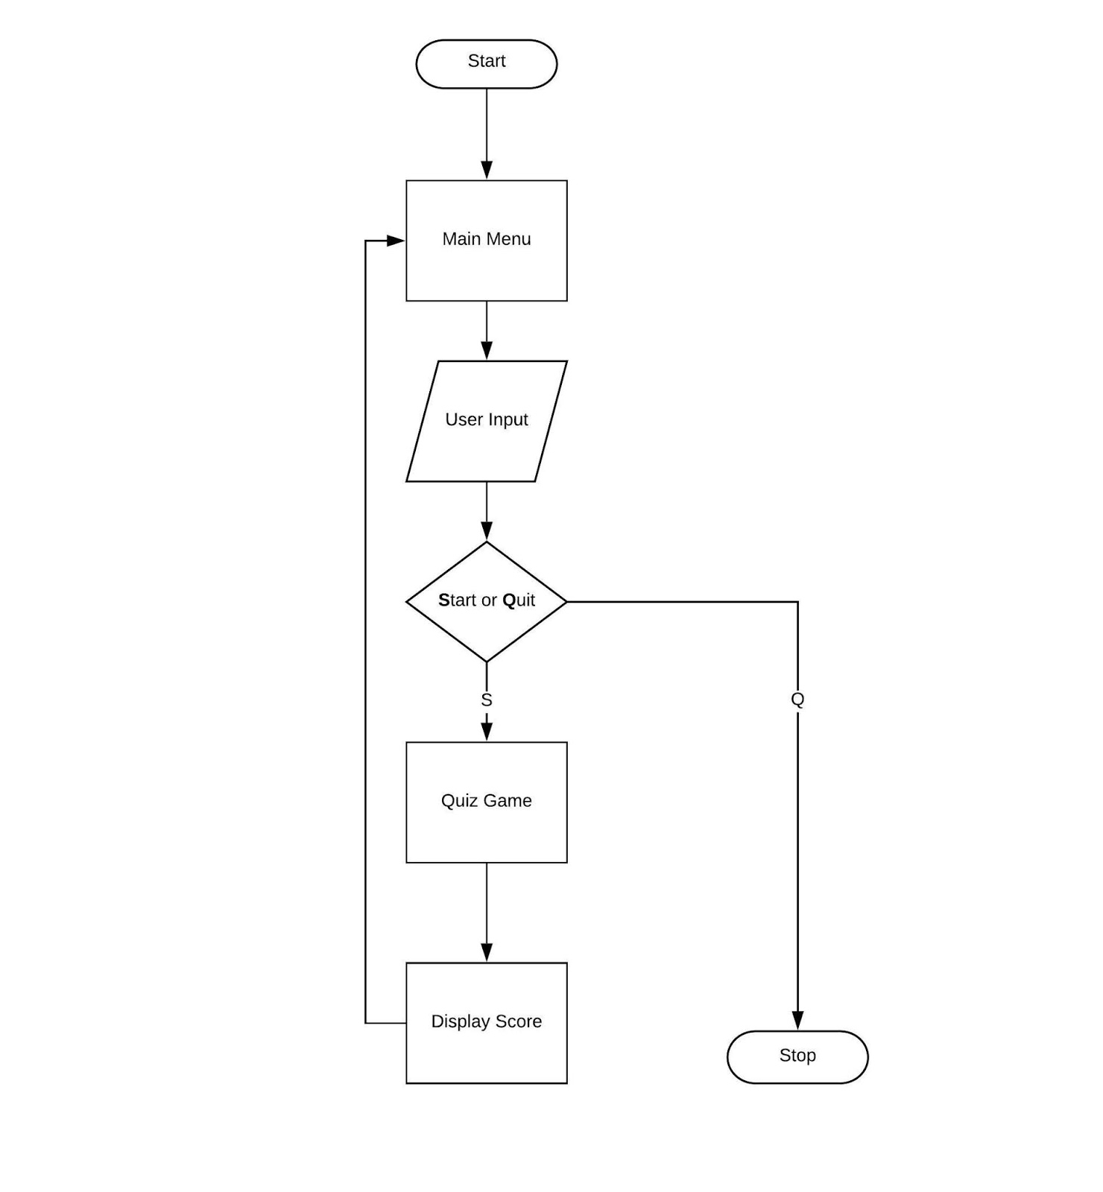

**PROJECT OUTCOMES**

### THE OUTCOMES OF JAVA BRAINS IS TO:

### It engage audience

Engage your audience in a unique and fun way and connect them to your brand or learning material. By creating a returning event, you will improve your consumer loyalty.

### It leads to simultaneous participation in Large number

Taking online quizzes makes it possible to have a large number of participants. It could be up to a number of 1000 participants (and even more!). It doesn’t matter at what kind of location they take the online quiz as long as

they are connected to the Internet.

### It can serve Random questions

It is significant more easy to randomize your question with just one click than to do it all manually. Randomizing questions and even answers of those questions is not a lot a of work to do with online quizzes. Besides the advantage of time saving, it also helps preventing students from [cheating](https://www.onlinequizcreator.com/knowledge-center/online-exam-center/how-to-prevent-cheating-on-an-online-exams-and-tests/item10616).

### And, Quiz results/ gain insight in audience

Another plus of online quizzes is getting immediate results from your participants. Not only does the creator get the results, the participant itself is also possible to get his or her results. This makes it for the creator easy to identify the gaps in knowledge. The participants are able to view on what kind of section they have to improve themselves.

**PROPOSED TIME DURATION**

* 25th September – 10th October: Login Page
* 11th October – 25th October: Rules Slide
* 26th October-10th November: Quiz Slide
* 11th November- 15th November: Score Page and Project completion**.**

**REFERENCES**

1. [Introduction to Java Swing - GeeksforGeeks](https://www.geeksforgeeks.org/introduction-to-java-swing/)
2. [Java AWT Tutorial (geeksforgeeks.org)](https://www.geeksforgeeks.org/java-awt-tutorial/)
3. Java: The Complete Reference, Twelfth Edition, 12th Edition

by Herbert Schildt.

PROPOSED TIME DURATION: 1-1.5 MONTH